[1]

A ZMP approach based on explicit LQR tracking and task space for the walking of a lower-limb rehabilitation exoskeleton

G. Garcia-Chavez, E. Choquehuanca-Perca, P. Miranda-Pereira, L. Milián-Ccopa

*Abstract*— This study presents the control law based on ZMP and LQR for a biped robot or a rehabilitation exoskeleton. The model is presented as a 7-link system with six actuated joints. The kinematics and dynamics analysis was divided into two parts: serial and parallel. The system was linearized using Task Space feedback linearization method, and trajectory tracking optimal control was de-signed using the LQR control strategy in the ZMP by directly controlling the CoM, solving the differential equation, finding CoM trajectories, and deleting the unstable terms. In contrast to another common methods, our approaches works relatively nice, and it’s a good way to generalize ZMP trajectories, no necessarily polynomials as is usually done. Simulations were performed in a virtual reality environment with human body inertial parameters obtained from previous studies and references by video recording analysis.

*Keywords— ZMP Control, kinematics, dynamics, control, feedback linearization, LQR, computed torque, biped, biomechanics, lower limb exoskeleton, walking rehabilitation.*

# INTRODUCTION

In the last years, there has been a growing interest in using robotic devices in gait assitance and rehabilitation of elderly, injured or disabled people.

Since lower limb exoskeleton can provide additional power in case of muscular weakness and make repetitive steered movements [1,2], it can be involved in most stages of therapy programs for paraplegic or quadriplegic people [3]. Furthermore, it is possible to monitor rehabilitation progress [4] by getting data of the patients from the measurements of the exoskeleton.

Regarding exoskeleton – user system balancing problem, a self-stabilizing controller for the vertical balance is needed. The controller has to avoid falling down within walking, so that, it is used zero-moment-point (ZMP) concept to define trajectories and to improve the dynamic stability of a humanoid robot [5, 6].

ZMP control is widely applied in bipedal robots and exoskeleton system. Now-adays, it is also possible to combine this method with other control strategies. In [7] a closed form solution for the LQR problem with ZMP polynomials trajectories was performed. It was applied to the ATLAS biped robot. In this paper, we propose a change of variables, by changing the mode to an autonomous time-invariant system. It is solved for a general function, under the assumption that a related integral has a explicit form.

# Background

## Human Gait

Human gait can be described as the forward propulsion of the centre of gravity based on rhythmic movements of lower-limbs [8]. It is divided into two phases: stance phase and swing phase as described in [9]. Given that during double sup-port period, two legs are in contact with the ground, we only focus on the stability of the exoskeleton within the simple support period.

## ZMP dynamics

Walking, in general is a hard task to accomplish because of the instability of the body at every step, a way to overcome this problem is to use the Zero Moment Point Approach. It is based on the fact that, for an stable static stand, it’s necessary that the Center of Mass (CoM) of the person is in the support polygon (smallest convex region which contains feet). In [6], a similar approach is used, not using the Centre of Mass, but the Center of Pressure of the contact forces, also known as Zero Moment Point (ZMP). According to [10], under the assumption $\ddot{θ}≈0$ the equation

$$x_{zmp}=x_{cm}-\frac{z_{cm}}{{\ddot{z}}_{cm}+g}{\ddot{x}}_{cm}$$

In the $x$ axes, which is also valid for $y$ axes. Using the assumption that we have the height of the center of mass at a constant value $z_{cm}=h$, which implies ${\ddot{z}}_{cm}=0$, we have:

$$x_{zmp}=x_{cm}-\frac{h}{g}{\ddot{x}}_{cm}, y_{zmp}=y_{cm}-\frac{h}{g}{\ddot{y}}_{cm}$$

With $g$ the gravity constant. Assuming that the CM can be controllable, the planar and COM and ZMP dynamics can be formulated according to [7] as follows:

$$\dot{x} =Ax+Bv_{cm}$$

$\dot{x}=\left[\begin{matrix}0_{2x2} & I_{2x2} \\ 0_{2x2} & 0_{2x2}\end{matrix}\right]x+\left[\begin{matrix}0_{2x2} \\ I_{2x2}\end{matrix}\right]v_{cm}$ (1)

$$y=Cx+D(X,v_{cm})$$

$$y=\left[\begin{matrix}0_{2x2} & I_{2x2}\end{matrix}\right]x+\frac{{-z}_{com}}{{\ddot{z}}_{com}+g}I_{2x2}v_{cm} (2)$$

Where:

$$x={\left[\begin{aligned}x_{cm}& y_{cm}& {\dot{x}}_{cm} {\dot{y}}_{cm}\end{aligned}\right]}^{T},v_{cm}={\left[\begin{aligned}v_{1}& v_{2}\end{aligned}\right]}^{T}$$

And $y$ are the components of the ZMP. Assuming that the COM is a constant value $z_{com}=h$, eq (2) is reformulated as follows:

$$y=\left[\begin{matrix}0_{2x2} & I_{2x2}\end{matrix}\right]x+\frac{-h}{g}I_{2x2}v_{cm} (3)$$

# Kinematical analysis

The exoskeleton is composed of 7 links: 3 links for each leg, and a back joining the hips. The actuators are placed as follows: one per ankle, one per knee and two in each hip, in pitch and roll axes, creating an 8 DoF robot. The addition of 2 extra joints at each hip, allows the control of the CoM in the frontal plane. The following considerations have been made:

### We assume both joints in each hip are placed in the same location in the space, connected by massless, 0-length and 0-inertia links.

### The others 7 links are rigid and have mass.

### The angular position, velocity and acceleration are saturated to human normal limits

### Stance and swing phases are alternating in each leg.

### Walking takes place on a flat and antiskid surface, with enough friction coefficient to avoid the foot slides.

### The model is considered just as a simple support, with alternating the legs (0 sec. for double supports)

## A. Simple support model

In this case, one leg supports the body. The robotic system is represented by a serial approach with the supported heel and toe fixed to the ground. (Fig 1) shows the axes placed, following the natural movements of the joints. Z axes are placed according to the orientations of the angles (fig. 1) and the right-hand rule, and in order to maintain the relationship among body parameters, centre of mass, mass and inertia moment of the trunk were divided and relocated in two parts.

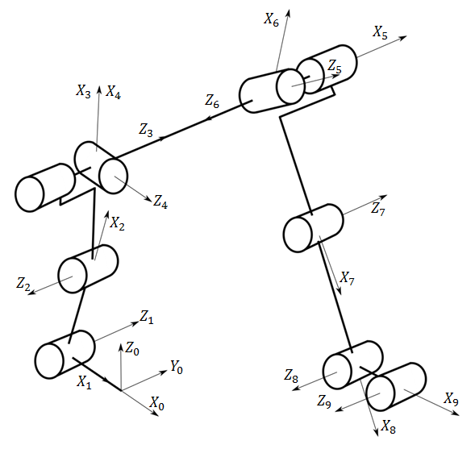

1. 8DoF Exoskeleton in the Simple support period
2. Angles orientations considerated in supports

|  |  |
| --- | --- |
| **Angles** | **Orientations** |
| $$θ_{1}$$ | + dorsal flexion, - plantar flexion |
| $$θ_{2}$$ | + flexion, - extension |
| $$θ_{3}$$ | + flexion, - extension |
| $$θ_{4}$$ | + extension, - flexion |
| $$θ_{5}$$ | + flexion, - extension |
| $$θ_{5}$$ | + flexion, - extension |
| $$θ_{7}$$ | + flexion, - extension |
| $$θ_{8}$$ | + dorsal flexion, - plantar flexion |

# Dynamical analysis

Some authors [11-13] have analysed the dynamics parameters of human body, and have estimated its dynamic properties. They are necessary to obtain the dynamical system to be controlled. In this study, Zatsiorsky-Leva [14] parameters are used. It shows length, mass, centre of mass position of each segment, and rotation radio in each plane. We also assume, taking into account [14], that the weight of the exoskeleton will increase the mass and inertia in 50% the value of the parameters, so we multiply them in the simulation by $1.5$.

Lagrangian mechanics was chosen due to its mechanical and computational scalability [15,16]. Since Lagrangian is the difference between the kinetic energy $T$ and the potential energy $V$ of the system (4), generalized torques (5) of the 8 active actuated joints in simple support phase are calculated as follow.

$$L=T-V=L\left(q_{\left(t\right)},{\dot{q}}_{\left(t\right)}\right) (4)$$

$T=\sum_{i=0}^{6}{\frac{1}{2}\left(v_{i}^{T}m_{i}v_{i}\right)+\frac{1}{2}(ω_{i}^{T}I_{i}ω_{i})}$, $V=-\sum_{i=1}^{6}{m_{i}g^{T}C_{i}}$

Then the Lagrange equation is:

$$\frac{d}{dt}\left(\frac{∂L\left(q_{\left(t\right)},{\dot{q}}_{\left(t\right)}\right)}{∂{\dot{q}}_{i}}\right)-\frac{∂L\left(q_{\left(t\right)},{\dot{q}}_{\left(t\right)}\right)}{∂q_{i}}=τ_{i}\left(t\right); 1≤i≤6 (5)$$

With i each joint $q_{i}=θ_{i}$. Equation 5 can be reordered to get:

$$τ\left(t\right)=M_{s}(q)\ddot{q}\left(t\right)+C_{s}(q,\dot{q})\dot{q}\left(t\right)+h_{s}(q) (6)$$

# Control Law

In order to perform a trajectory-tracking control of the exoskeleton we performed task space feedback linearization [17] to transform the plant to a linear one. Then we use a trajectory-tracking controller, first changing the coordinates to the tracking error using the references functions ($q_{d}(t), {\dot{q}}_{d}(t),{\ddot{q}}_{d}(t)$), and over the new coordinates, we use the Riccati Equation, LQR in order to obtain an optimum controller.

## Task Space Feedback Linearization

In order to control the components of the robot we use a Task Space Feedback Linearization with $z∈R^{8}$:

$$z=f\left(q\right) (7)$$

Which is a transformation in new coordinates which contains the center of mass to control directly as follows:

$$f\left(q\right)={\left[\begin{matrix}x_{cm} & y_{cm} & z_{cm} & θ_{cm} & q_{1} & q_{6} & q_{7} & q_{8}\end{matrix}\right]}^{T}$$

Let’s analyze each part: The first three components $f$ containsthe coordinates in three dimensions of the center of mass defined by:

$$r_{cm}=\frac{\sum_{i}^{n}{{r_{cm}}_{i}m_{i}}}{\sum_{i}^{n}{m_{i}} } (8)$$

Where ${r_{cm}}_{i}∈R^{3}$ is the position of the center of mass of each link of the robot in the space. $f$. The fourth is the Angle of the center of mass, which is considered the angle of the back respect the vertical (because has the largest mass). The last three terms are just the angles

Taking derivative of $z$**:**

$$\dot{z}=\frac{∂f}{∂q}\dot{q}$$

Setting the Jacobian $\frac{∂f}{∂q}$ as $J$, and taking derivative again:

$$\dot{z}=J(q)\dot{q}$$

$$\ddot{z}=\dot{J}\left(q\right)\dot{q}+J\left(q\right)\ddot{q}$$

As we know from the dynamic analysis:

$$\ddot{q}=M^{-1}\left(q\right)\left(τ-C\left(q,\dot{q}\right)\dot{q}-G\left(q\right)\right) (9)$$

Replacing on ():

$$\ddot{z}=\dot{J}\left(q\right)\dot{q}+J\left(q\right)M^{-1}\left(q\right)\left(τ-C\left(q,\dot{q}\right)\dot{q}-G\left(q\right)\right)$$

Setting $η$ **and $γ$ as:**

$$η\left(q,\dot{q}\right)=\dot{J}\left(q\right)\dot{q}-J\left(q\right)M^{-1}\left(q\right)\left(C\left(q,\dot{q}\right)\dot{q}+G\left(q\right)\right), γ\left(q\right)=J\left(q\right)M^{-1}\left(q\right)$$

We have the dynamical system:

$$\ddot{z}=η\left(q,\dot{q}\right)+γ\left(q\right)τ (10)$$

In order to linearize the system, we set the control input as:

$$τ=γ^{-1}\left(q\right)\left(v-η\left(q,\dot{q}\right)\right) (11)$$

Which is possible when the matrix $γ\left(q\right)$ is invertible, which happens if and only if the jacobian of the transformation $J(q)$ is invertible, which is equivalent to the fact if solution the inverse kinematic problem is feasible in a neighbourhood of the actual point. This is, if and only if the jacobian is invertible. Considering $v∈R^{8}$ as the new input variable, and taking into account that the inertia matrices $M$ are invertible, the new dynamical system is:

$$\ddot{z}=v (12)$$

Setting a state variable $x∈R^{16}$ as $x={\left[\begin{aligned}z& \dot{z}\end{aligned}\right]}^{T}$ we have:

$$\dot{x}=Ax+Bv \left(13\right)$$

$$y=Cx+Dv$$

Where:

$$A=\left[\begin{matrix}0_{8x8} & I_{8x8} \\ 0_{8x8} & 0_{8x8}\end{matrix}\right];B=\left[\begin{aligned}0_{8x8} \\ I_{8x8}\end{aligned}\right]$$

$$C=\left[\begin{matrix}0_{8x8} & I_{8x8} \\ 0_{8x8} & 0_{8x8}\end{matrix}\right];D=\left[\begin{aligned}0_{8x8} \\ I_{8x8}\end{aligned}\right]$$

## Trajectory Tracking for Center of Mass

One way to do Trajectory Tracking is changing the variables to the errors of tracking.

As we know, the matrix $f$ has the components of the Zero Moment Point. Decoupling the system showed in $(13)$ we can extract the components of the center of mass:

$$\begin{matrix}{\dot{x}}_{cm}=A_{1}x_{cm}+B_{1}v_{cm} \\ y=C_{1}x_{cm}+D_{1}v_{cm}\end{matrix} \left(13\right)$$

Based on the equivalence of the output $y$:

$$x_{zmp}=x_{cm}-\frac{h}{g}{\ddot{x}}_{cm}$$

The problem of tracking $y$ is equivalent to track the center of mass to a trajectory $f\left(t\right)∈R^{2}$ that depends on the desired trajectory of the ZMP as follows (Note that f here is not bolded).

$$f\left(t\right)-\frac{h}{g}\ddot{f}\left(t\right)=y^{d}(t)$$

The differential equation is the same as ZMP. In consequence, the acceleration of the center of mass will track $\ddot{f}(t)$, that means, the variable $v_{cm}$ must track $\ddot{f}(t)$

For that reason, now we’ll change the coordinates to the following ones:

$$e=x_{cm}-f\left(t\right), v_{e}=v_{cm}-k\left(t\right), y_{e}=y-y^{d}(t)$$

$e$ represents an error, and in the following, the e subscripts will do it as well, while $f$ is a solution to the ZMP differential equation. In particular, we’ll choose $f$, and in consequence $k$ as follows:

$$f\left(t\right)=c_{1}e^{λt}-λ\int_{0}^{t}{\sinh\left(λ\left(t-r\right)\right)y^{d}(r)dr}$$

$$k\left(t\right)=λ^{2}c_{1}e^{λt}-λ^{2}y^{d}(t)-λ^{3}\int_{0}^{t}{\sinh\left(λ\left(t-r\right)\right)y^{d}(r)dr}$$

With $λ=\sqrt{\frac{g}{h}}$ and $c_{1}=\frac{λ}{2}\int_{0}^{∞}{e^{-λt}y^{d}\left(t\right)dt}$ (This requires $y^{d}$ to be exponential order) . We found this by using Laplace Transform to the differential equation:

$$f\left(t\right)-\frac{h}{g}\ddot{f}\left(t\right)=y^{d}\left(t\right)$$

$$\left(s^{2}-λ^{2}\right)F\left(s\right)=sf\left(0\right)+f^{'}(0)-λ^{2}Y^{d}(s)$$

We wish $f$ to not be an exponential growing for any $y^{d}$, so for that we must delete the pole $s=λ>0$ by equalling the LFT to zero.

$$λf\left(0\right)+f^{'}\left(0\right)-λ^{2}Y^{d}\left(λ\right)=0$$

Taking into account that the particular solution $f_{p}$ holds $f_{p}\left(0\right)=f_{p}^{'}\left(0\right)=0$, using one of the homogeneous solution we have:

$$2λc_{1}-λ^{2}Y^{d}\left(λ\right)=0→c_{1}=\frac{λ}{2}\int_{0}^{∞}{e^{-λt}y^{d}\left(t\right)dt}$$

For polynomial trajectories, both, the term $c_{1}$ and the integral in $f$ have a closed form, so we can track the center of mass to the functions mentioned above use them.

It’s easy to prove that between both functions the following relationships holds:

$$\ddot{f}\left(t\right)=k\left(t\right); f\left(t\right)-\frac{1}{λ^{2}}k\left(t\right)=y^{d}\left(t\right)$$

$$λ=\sqrt{\frac{g}{h}} ; f\left(t\right)-\frac{h}{g}\ddot{f}\left(t\right)=y^{d}(t)$$

Where $y^{d}$ are the desired components of the ZMP

Using these properties we have:

$$x_{e}=\left[\begin{aligned}e \\ \dot{e}\end{aligned}\right]=\left[\begin{aligned}x_{cm}-f\left(t\right) \\ {\dot{x}}_{cm}-\dot{f}\left(t\right)\end{aligned}\right]$$

$${\dot{x}}_{e}=\left[\begin{aligned}\dot{e} \\ \ddot{e}\end{aligned}\right]=\left[\begin{aligned}\dot{e} \\ {\ddot{x}}_{cm}-g(t)\end{aligned}\right]=\left[\begin{aligned}\dot{e} \\ v_{cm}-g(t)\end{aligned}\right]=\left[\begin{aligned}\dot{e} \\ v_{e}\end{aligned}\right]$$

$$\begin{matrix}{\dot{x}}_{e}=A_{1}x_{e}+B_{1}v_{e} \\ y_{e}=C_{1}x_{e}+D_{1}v_{e}\end{matrix} \left(13\right)$$

## Trajectory tracking for sagittal

Recalling (7):

$$z=f(q)$$

We know the third component is the height of the center of mass, we need it to be constant to hold the condition of simplifications of ZMP. So in equation (12), taking the third component, we make the following change:

$$z_{3e}=z_{3}-h$$

$${\ddot{z}}_{3e}=v_{3}$$

We can see that the dynamical equation doesn’t change, similarly, $z_{4}$, the angular component of the robot, which holds:

$$z_{4}=-q_{1}+q_{2}-q_{3}→z_{4e}=-q_{1}+q_{2}-q_{3}-θ^{d}$$

With $θ^{d}=-q_{1}^{d}+q_{2}^{d}-q_{3}^{d}$ so:

$${\ddot{z}}_{4e}=v_{4}-(-{\ddot{q}}_{1}^{d}+{\ddot{q}}_{2}^{d}-{\ddot{q}}_{3}^{d})$$

Changing again; $v_{4}=\left(-{\ddot{q}}_{1}^{d}+{\ddot{q}}_{2}^{d}-{\ddot{q}}_{3}^{d}\right)+v_{4e}$ where $v_{4e}$ is the new control input. Note that all the transformations performed before are equivalent to a total change of variable as follows:

The other 4 variables of $f$ are the angles $q_{1}, q_{6}, q_{7}, q_{8}$:

Similarly:

$$z_{5}=q_{1}^{d}+z_{5e}; z_{i}=q_{i}^{d}+z_{ie}$$

$$v_{5}={\ddot{q}}_{1}^{d}+v_{5e}; v_{i}={\ddot{q}}_{i}^{d}+v_{ie}$$

For $i=6,7,8$, where $q_{i}^{d}$ is the desired trajectory of each joint, obtained by video analysis in [9]

Note that all the transformations performed before are equivalent to a total change of variable as follows:

$$z=f\left(q\right)=z_{e}+z^{d}\left(t\right)→z_{e}=z-z^{d}(t)$$

$$z_{e}={\left[\begin{matrix}x_{e} & y_{e} & z_{e} & θ_{e} & q_{1e} & q_{6e} & q_{7e} & q_{8e}\end{matrix}\right]}^{T}$$

$$z^{d}\left(t\right)={\left[\begin{matrix}f_{1}\left(t\right) & f_{2}\left(t\right) & h & θ^{d} & q_{1}^{d} & q_{6}^{d} & q_{7}^{d} & q_{8}^{d}\end{matrix}\right]}^{T}$$

And in $v:$

$$v=v_{e}+{\left[\begin{matrix}k_{1}\left(t\right) & k_{2}\left(t\right) & 0 & v_{4}^{d} & {\ddot{q}}_{1}^{d} & {\ddot{q}}_{6}^{d} & {\ddot{q}}_{7}^{d} & {\ddot{q}}_{8}^{d}\end{matrix}\right]}^{T}$$

$$v=v_{e}+v^{d}\left(t\right)$$

$$v_{e}=v-v^{d}(t)$$

Where $f_{1}, f_{2}$ are the components of the function $f$ founded before in the differential equation, and $k_{1}$ and $k_{2}$ the components of $k$.

In order to achieve trajectory tracking, we consider equation (12), and define $v_{d}∈R^{8}$ and $x_{d}∈R^{16}$ as control trajectory and the desired states from references. We also consider $x_{e}=\left[\begin{aligned}z_{e} \\ {\dot{z}}_{e}\end{aligned}\right]∈R^{16}$ and $v_{e}∈R^{8}$, as the tracking error.

$$x={\left[\begin{aligned}z_{e} &{\dot{z}}_{e}\end{aligned}\right]}^{T} , x_{d}={\left[\begin{aligned}q_{d}&{ \dot{q}}_{d}\end{aligned}\right]}^{T}$$

$$\begin{matrix}v_{d}={\ddot{q}}_{d}, x_{e}=x-x_{d}, v_{e}=v-v_{d}\end{matrix} \left(14\right)$$

Then, we can replace the new variables in the space state system as (15) shows.

$${\dot{x}}_{e}=Ax_{e}+Bv_{e} (15)$$

The objective now is to drive the error $x_{e}$ to $0$ using $v_{e}$, which also goes to zero using an optimal controller LQR.

## LQR Design

An LQR controller [18] is a method that finds the best control input to minimize a cost function, defined as follows:

$$J=\int_{0}^{∞}{x^{T}Qx+u^{T}Ru dt}$$

Where Q is a positive-definite (or positive semi-definite) and R is a positive-definite symmetric matrix.

Form LQR theory we know that, in the case of infinite horizon $t_{f}→∞$ the optimal controller that minimizes 𝐽 is:

$$u\left(t\right)=-Kx(t)$$

Where K is a matrix satisfying:

$$K=R^{-1}BP$$

$$A^{T}P+PA-PBR^{-1}B^{T}P+Q=0$$

$P$ satisfies the last equation, called Riccati algebraic equation. Applying LQR on our system (15), we define the controller as:

$$v_{e}=-Kx_{e} (16)$$

$$v=-Kx_{e}+v_{d} (17)$$

Replacing (17) in (11) the controller in the original plant is:

$$u=C\dot{q}+h+M\left({\ddot{q}}_{d}-Kx_{e}\right) (18)$$

+

+

+

-

$$x_{d}$$

$$x_{e}$$

$$-K$$

$${\ddot{q}}_{d}$$

$$v$$

$$u$$

$$Feedback$$

$$Linearization$$

$$x$$

$$Exosqueleton$$

$$SP$$

$$LQR$$

$$Linear Plant$$

1. Trajectory Tracking with LQR Controller

All trajectory was simulated with random initial conditions and following the angular references from [9], we can see that approximately in the 30% and 33% (approx. 0.3-0.36 seg.) of the variable z errors goes to 0 (Fig. 3a). The exoskeleton was simulated as well, with random initial conditions, we can see again that errors goes to zero (Fig. 3b), this time in the 5% and 6% (approx. 0.1-0.12 seg.) of the gait and without oscillations. Therefore, it follows the angles trajectory nicely and, in consequence, the trajectory in the space (sagittal plane).

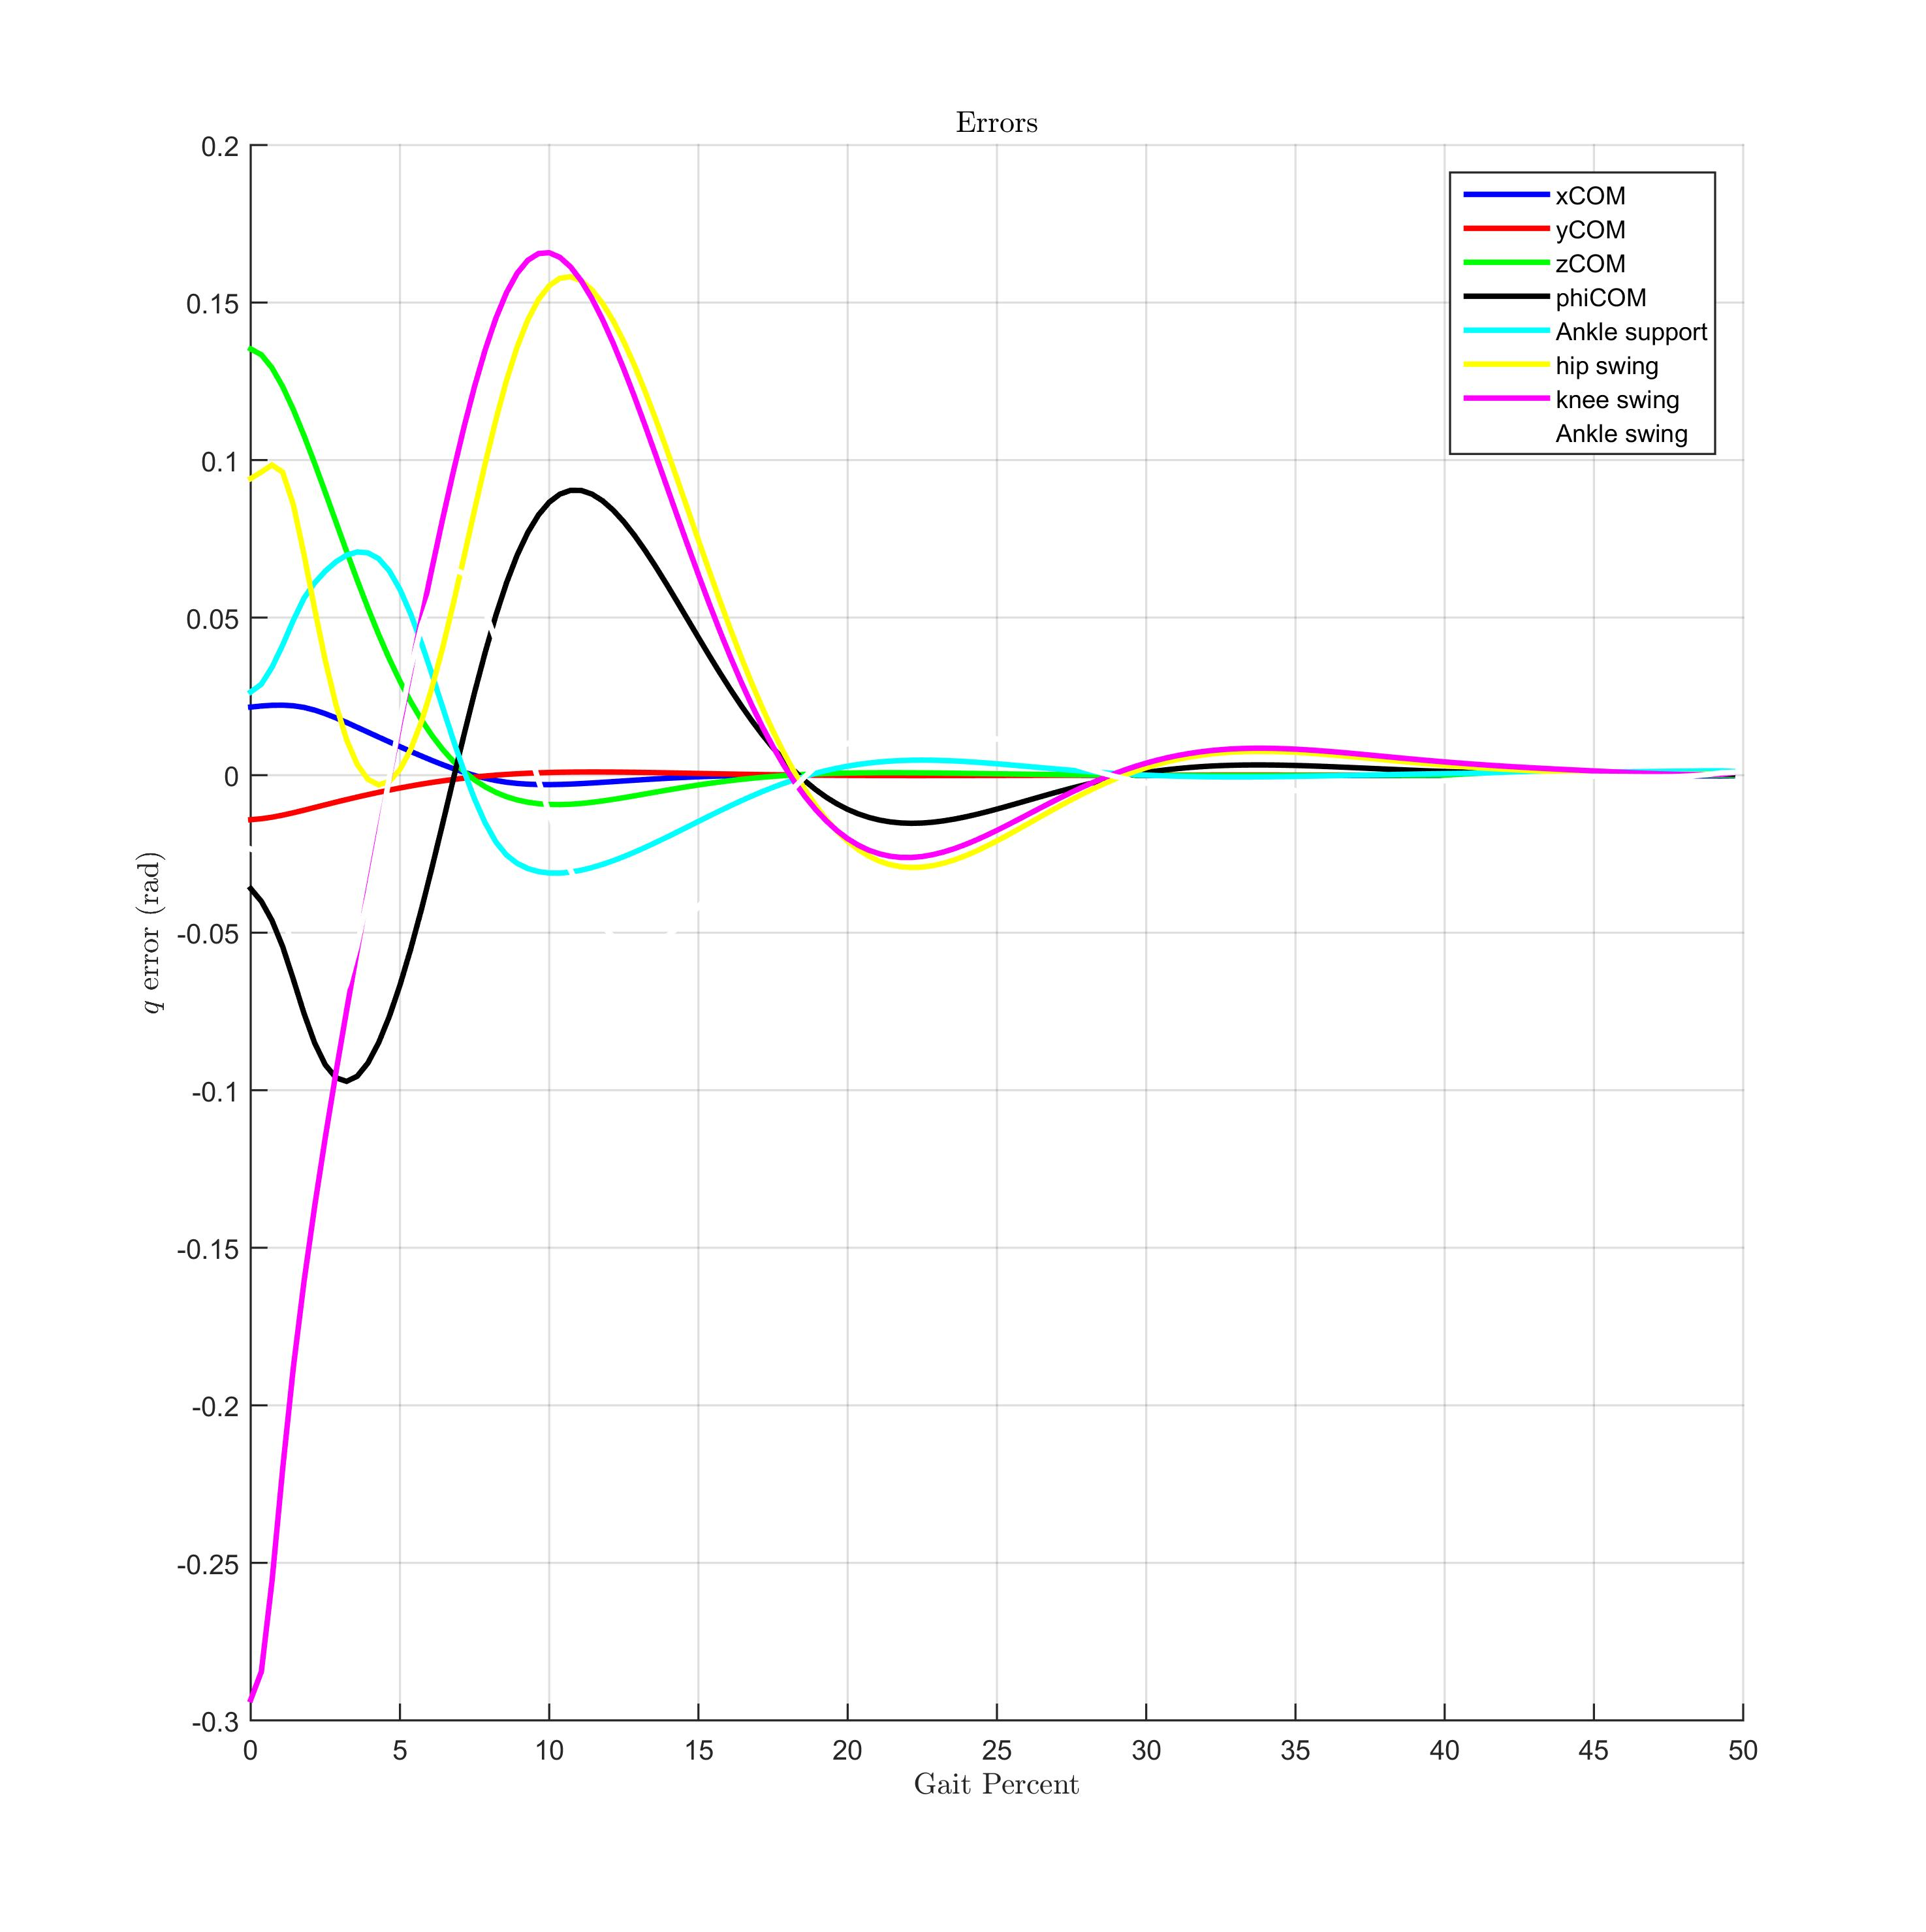

1. States errors

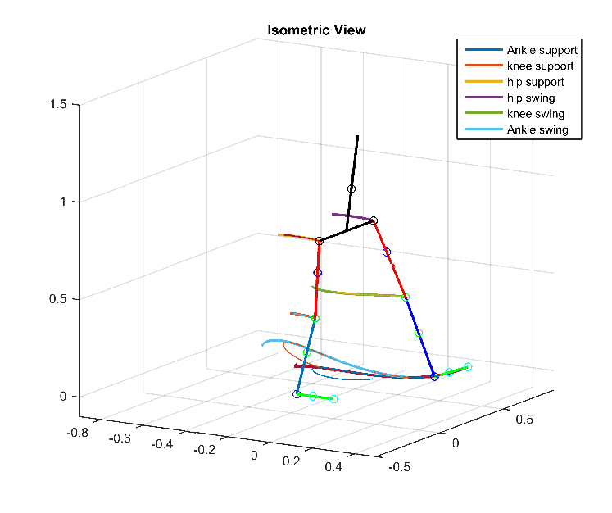

1. Simulation in xyz space. Thin line represents the simulated trajectory, while the thick line repre-sents the reference and the values computed by the zmp.

# CONCLUSIONS

We design an optimal trajectory-tracking controller based on Feedback Linearization and LQR method for the trajectory problem of the ZMP by directly controlling the CoM. In contrast to another methods, it’s a new method in the literature our approaches works relatively nice, and it’s a good way to generalize ZMP trajectories no necessarily polynomials. This helps in the rehabilitations of the stroke patients, but they must adapt to the new kind of walking. So the future work will be centered in people who will learn about how to use and adapt itself to the exoskeleton, controlling its back and the back of the embodied system.

Acknowledgment

Special thanks to The Research Institute of the Mechanical Engineering Faculty (INIFIM), National Institute of Research and Training in Telecommunications (INICTEL) and the Biomechatronics Research and Innovation Group for the constantly support to our projects.

References

1. Y. Hayashi and K. Kiguchi, “Stairs-ascending/descending assist for a lower-limb power-assist robot considering zmp,” in *2011 IEEE/RSJ International Conference on Intelligent Robots and Systems*. IEEE, 2011, pp. 1755–1760.
2. Y. Sankai, “Hal: Hybrid assistive limb based on cybernics,” in *Robotics Research*. Springer, 2010, pp. 25–34.
3. G. Colombo, M. Joerg, R. Schreier, and V. Dietz, “Treadmill training of paraplegic patients using a robotic orthosis,” *Journal of rehabilitation research and development*, vol. 37, no. 6, p. 693, 2000.
4. I. Dáz, J. J. Gil, and E. Sánchez, “Lower-limb robotic rehabilitation: literature review and challenges,” *Journal of Robotics*, vol. 2011, 2011.
5. M. Sobotka and D. Wollherr and M. Buss, “A jacobian method for online modification of precalculated gait trajectories”, *in Proceedings of the 6th International Conference on Climbing and Walking Robots*, 2003, pp. 435-442.
6. Kajita, S., Kanehiro, F., Kaneko, K., Fujiwara, K., Harada, K., Yokoi, K., & Hirukawa, H. (2003). Biped walking pattern generation by using preview control of zero-moment point. *Robotics and Automation, 2003. Proceedings ICRA* . IEEE International Conference on, 2 (October), 1620--1626 vol.2
7. Tedrake, R., Kuindersma, S., Deits, R., & Miura, K. (2015). “A closed-form solution for real-time optimal gait generation and feedback stabilization” in *Humanoid Robots (Humanoids), 2015 IEEE-RAS 15th International Conference on,* IEEE, 2015.
8. J. Sánchez, J. Prat, J. V. Hoyos, E. Viosca, C. Soler, M. Comn, R. Lafuente, A. Cortés, and P. Vera, “Biomecánica de la marcha humana normal y patológica,” *Instituto de biomecánica de Valencia*, vol. 253, 1999
9. P. A. Miranda-Pereira and L. P. Milian-Ccopa, “Brief biomechanical analysis on the walking for a lower-limb rehabilitation exoskeleton,” in *To appear in: Robotics and Intelligent Sensors (IRIS), 2016 IEEE International Symposium on*. IEEE, 2016.
10. Tedrake, R., Kuindersma, S., Deits, R., & Miura, K. (2015). “A closed-form solution for real-time optimal gait generation and feedback stabilization” in *Humanoid Robots (Humanoids), 2015 IEEE-RAS 15th International Conference on,* IEEE, 2015.
11. W. H. Ho, T.-Y. Shiang, C. C. Lee, and S. Y. Cheng, “Body segment parameters of young chinese men determined with magnetic resonance imaging,” *Medicine and science in sports and exercise*, vol. 45, no. 9, pp. 1759–1766, 2013.
12. J. T. McConville, C. E. Clauser, T. D. Churchill, J. Cuzzi, and I. Kaleps, “Anthropometric relationships of body and body segment moments of inertia,” DTIC Document, Tech. Rep., 1980.
13. V. Zatsiorsky, V. Seluyanov, and L. Chugunova, “In vivo body segment inertial parameters determination using a gamma-scanner method,” *Biomechanics of human movement: Applications in rehabilitation, sports and ergonomics*, pp. 186–202, 1990.
14. P. De Leva, “Adjustments to zatsiorsky-seluyanov’s segment inertia parameters,” *Journal of biomechanics*, vol. 29, no. 9, pp. 1223–1230, 1996.
15. A. A. Shabana, Dynamics of multibody systems. Cambridge university press, 2013.
16. Computational *dynamics*. John Wiley & Sons, 2009.
17. M. W. Spong, S. Hutchinson, and M. Vidyasagar, *Robot modeling and control*. Wiley New York, 2006, vol. 3.
18. K. Ogata, “Modern control engineering,” 2002.

1. *Research supported by INIFIM-UNI.

   G. Garcia-Chavez is with the Biomechatronics Research Group of the National University of Engineering, Lima, Peru. (e-mail: [gabrconatabl@gmail.com](mailto:gabrconatabl@gmail.com)).

   E. Choquehuanca-Perca is with the Biomechatronics Research Group of the National University of Engineering, Lima, Peru. (e-mail: e05.sek@gmail.com).

   P. Miranda-Pereira is with the Biomechatronics Research Group of the National University of Engineering, Lima, Peru. (e-mail: pmirandap@uni.pe).

   L. Milian-Ccopa is with the Biomechatronics Research Group of the National University of Engineering, Lima, Peru. (e-mail: milepcco@gmail.com).